**Concur Data Conversion Universal**

User Manual

|  |  |
| --- | --- |
| Project | Concur Data Conversion Universal |
| Production | <http://10.192.44.42/cdc.universal/> |
| Developer | Vincent, Ke |
| Date | 2015/8/4 |
| Version | 1.0 |
|  |  |

### Introduction

#### Concur Data Conversion Tool

Concur is a world class solution to manage business travel and expenses for corporations. Ingersoll Rand adopts Concur for employee expense management.

The responsibilities of Concur Data Conversion Tool are as below:

* Import Concur interface files

Concur will export an interface file for each branch company (全球分公司) weekly. Ingersoll Rand handles the expense for each Entity using these interface files. So the first thing need to do is to import these Concur files into CDC database.

* Create ERP files

Because there are ERP systems in IR financial departments: including Oracle, MFG/Pro, SAP and PeopleSoft. So we need to create financial reports for these ERP systems accordingly. One entity should only have one type of ERP interface file.

* Create bank files

Also Concur Data Conversion will create bank interface files as needed. The bank files will be sent to the banks for finance payment for employees. Currently we have two type of bank files: the Standard Chartered Bank (渣打银行) and National City Bank of New York (CitiBank花旗银行)。

* Create PerDiem files

Concur Data Conversion will create PerDiem files which are used by HR to maintain the allowance (津贴) of employees, the allowance data is part of the salary data.

#### Concur Data Conversion Universal

Currently, each country has an independent Concur Data Conversion web application. So we have the following 12 applications now to handle the Concur data conversion. These applications have different database, different source code and application deployment. This way adds difficulty for support and maintainence.

* http://10.192.44.42/concur.au
* http://10.192.44.42/concur.china
* http://10.192.44.42/concur.gu
* http://10.192.44.42/concur.hk
* http://10.192.44.42/concur.ind
* http://10.192.44.42/concur.jp
* http://10.192.44.42/concur.kr
* http://10.192.44.42/concur.my
* http://10.192.44.42/concur.nz
* http://10.192.44.42/concur.ph
* http://10.192.44.42/concur.sgp
* http://10.192.44.42/concur.tw

On the other hand, these concur applications are developed by different contracts. So the coding style, supporting libraries are different. And for some applications, we even don’t have the latest version of source code, making it impossible to extend.

The goal of this universal concur data conversion will build an infrastructure that can be extended for different countries and areas. So the user will be working in a universal platform to handle the Concur data.

Performance improvement and user friendly experience are other key consideration for this new system. The new application will be accessed by: <http://10.192.44.42/cdc.universal>.

### User Authentication and Authorization

CDC Universal integrates domain account authentication for all users, so users will be asked to input the domain user name and password when accessing CDC Universal.

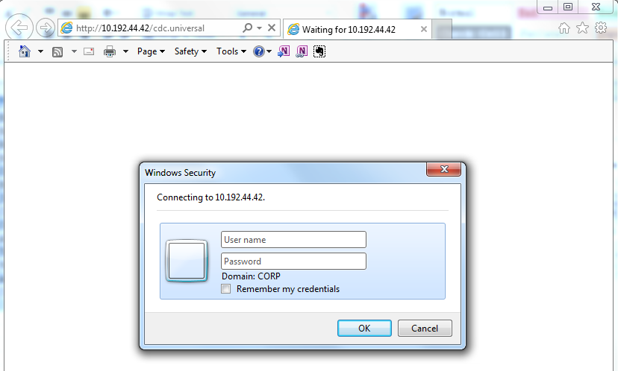

After successful login, you will notice your user account and user name on the top right of the screen. And the country list that you have permission on the right of the navigation bar. The first country will be selected by default. However, you can switch to other country at any time.

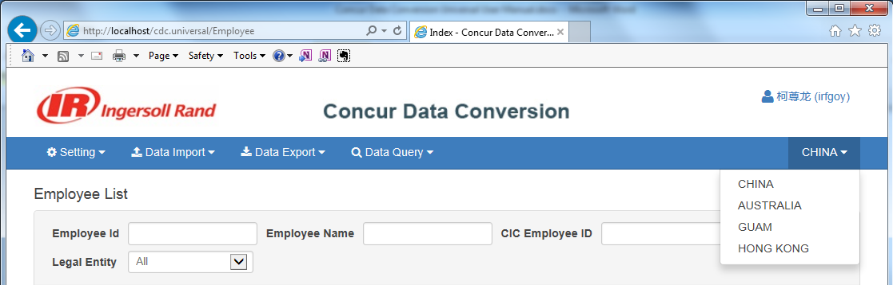

You can click your user name to view your detailed permissions as below. You can also edit your personal data on this page:

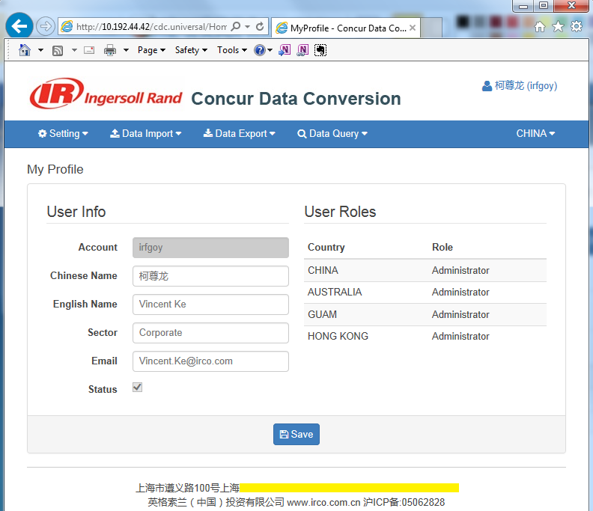

### Environment Setting

User can setup the environment through the Setting menu as below. The Administrators have the permission for Country Management and User Management. And Finance Administrators have permission for other setting items.

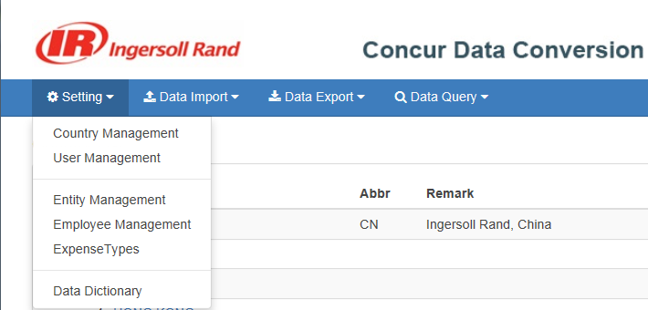

#### Country Management

It’s where to manage the country list. Administrators can add, update or delete countries as needed.

* Click the country name to view and edit country information.
* Click the Add Country button will navigate you to the New Country form.
* Click the Delete button will delete the selected Country.

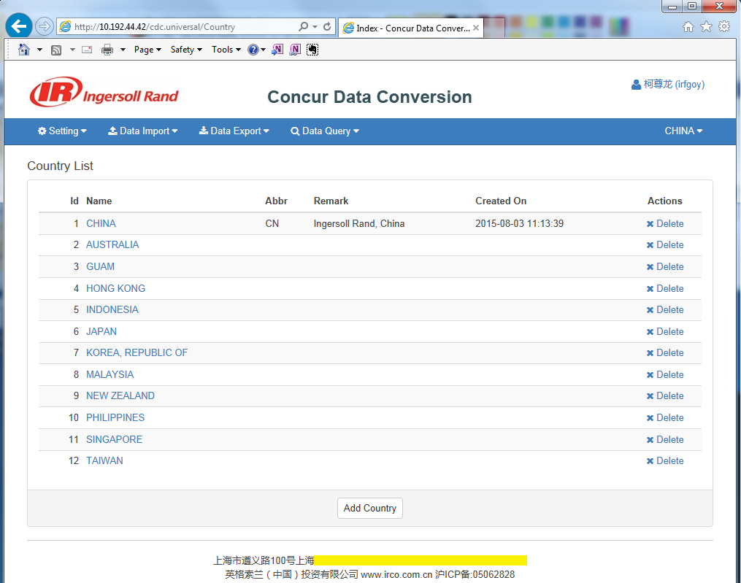

#### User Management

##### User List

Administrators can manage user information in this web page, including:

* Search users by user code, country and role data.
* Click the user code to view and edit user information.
* Click the Add User button will navigate you to the New User form.
* Click the Delete button will delete the selected User..

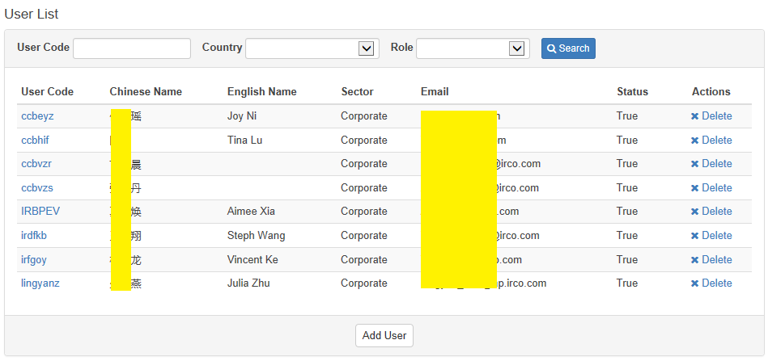

##### Create/Edit User

The Create New User form is as below, input the user data on the left and the role data on the right. Then click Save button the submit user data.

Edit User form is same, except that the Account property is read only.

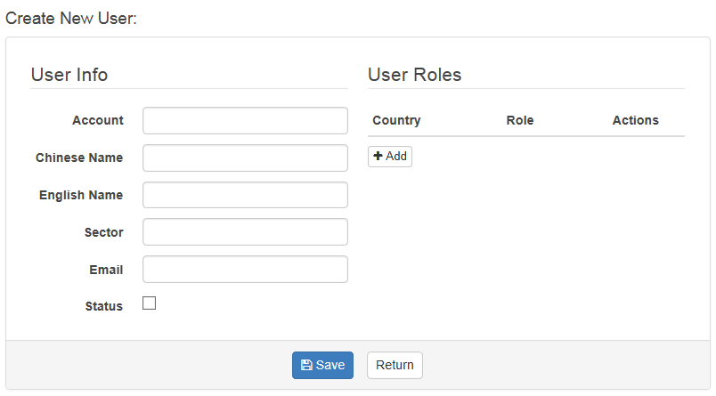

After click the Add button, you will see a dialog to select the user role.

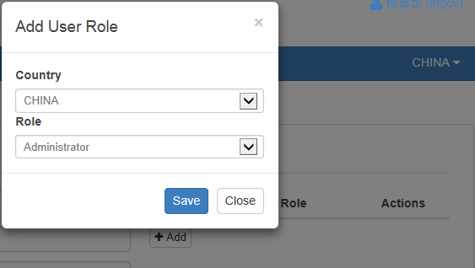

#### Entity Management

##### Entity List

Finance Administrators can manage entity information in this web page, including:

* Search entities.
* View and edit Entity information.
* Create a new Entity.
* Delete existing Entity.

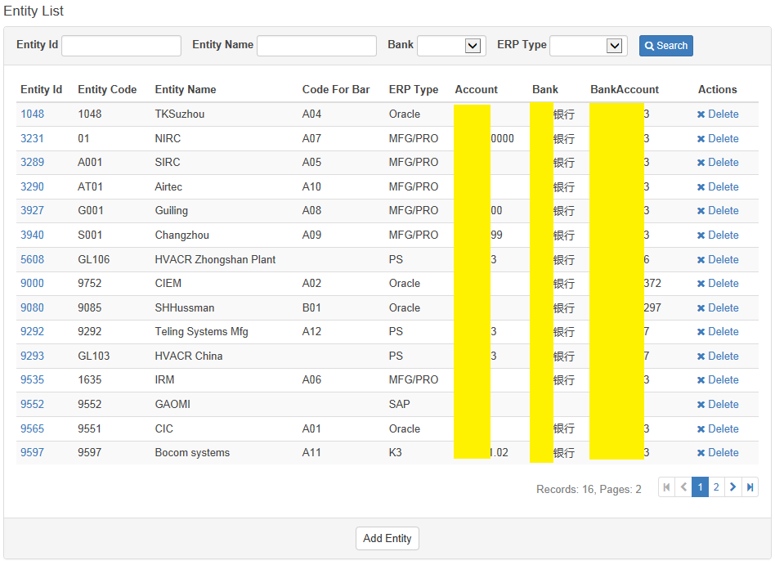

##### Create/Edit Entity

The Create/Edit Entity form is as below. Click the Save button to submit after you input the correct entity information. The Entity Id is read only in edit mode.

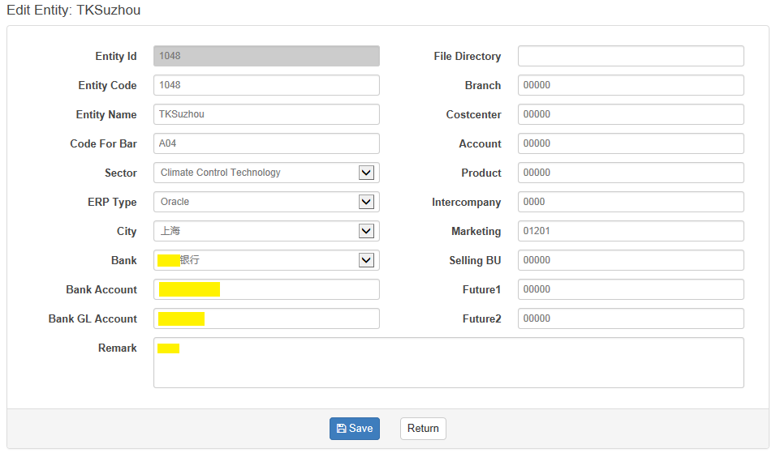

#### Employee Management

##### Employee List

Finance Administrators can manage employee information in this web page, including:

* Search employees.
* View and edit Employee information.
* Create a new Employee.
* Batch import multiple employees at one time.
* Delete existing Employee.

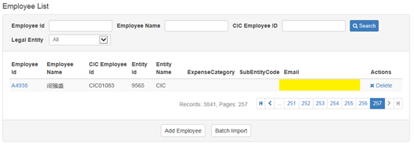

##### Create/Edit Employee

The Create/Edit Employee form is as below. Click the Save button to submit after you input the correct employee information. The Employee Id is read only in edit mode.

There are other roles can access this web page, including: FinanceBank and FinanceCreditCard. However, FinanceBank role will only be able to edit the bank information and FinanceCreditCard can only be able to edit the Credit information.

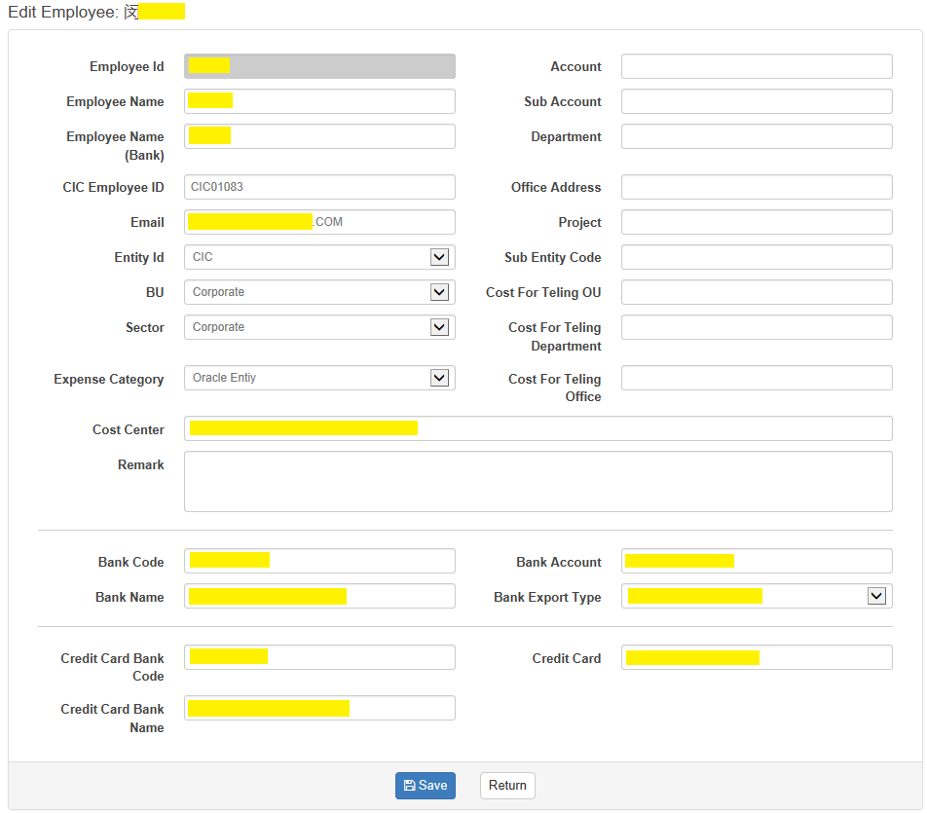

##### Batch Import Employees

Input employee information is a tedious and error-prone task, especially when a new Entity is created and there are hundreds of employees need to be added. So this batch import page is created to simplify the process, please according to the instruction on this web page to batch import employees.

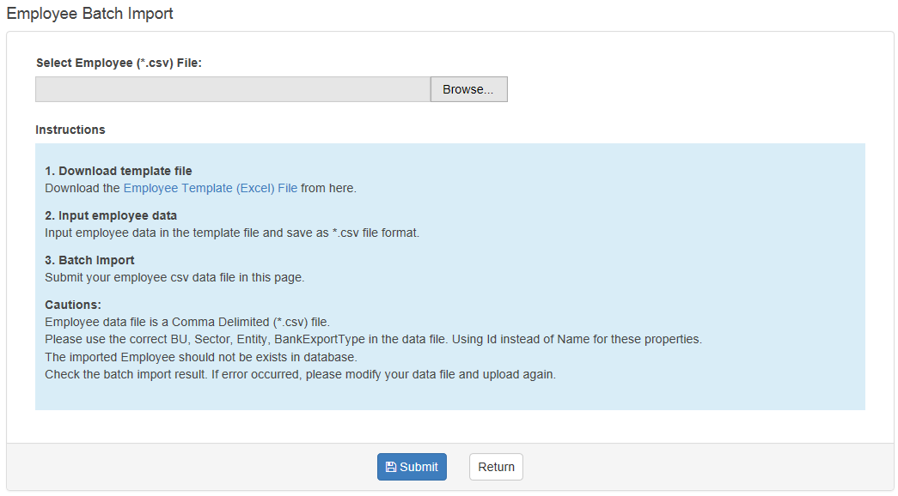

#### ExpenseType Management

##### ExpenseType List

Finance Administrators can manage expense type information in this web page, including:

* Search expense types.
* View and edit ExpenseType information.
* Create a new ExpenseType.
* Batch import multiple ExpenseTypes at one time.
* Delete existing ExpenseType.

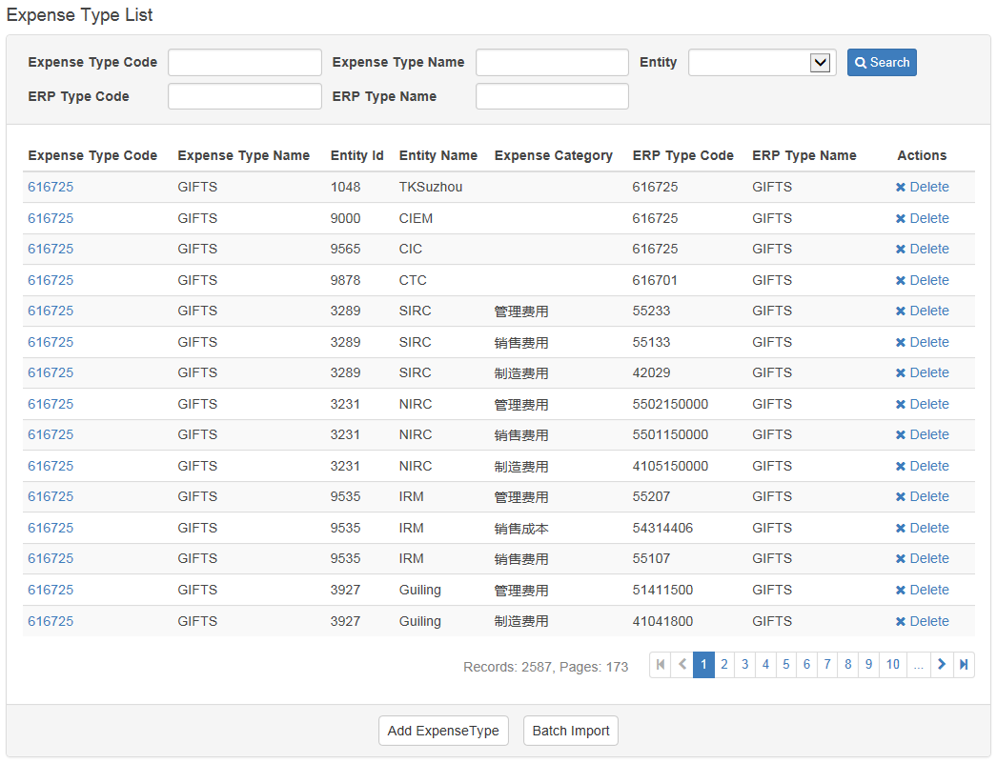

##### Create/Edit Expense Type

The Create/Edit ExpenseType form is as below.

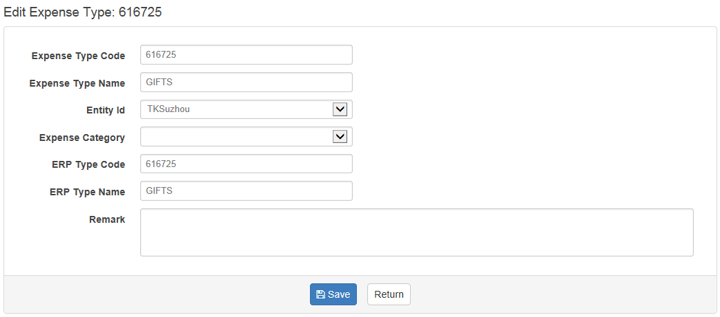

##### Batch Import Expense Types

Input expense type information is a tedious and error-prone task, especially when a new Entity is created and there are hundreds of expense types need to be added. So this batch import page is created to simplify the process, please according to the instruction on this web page to batch import expense types.

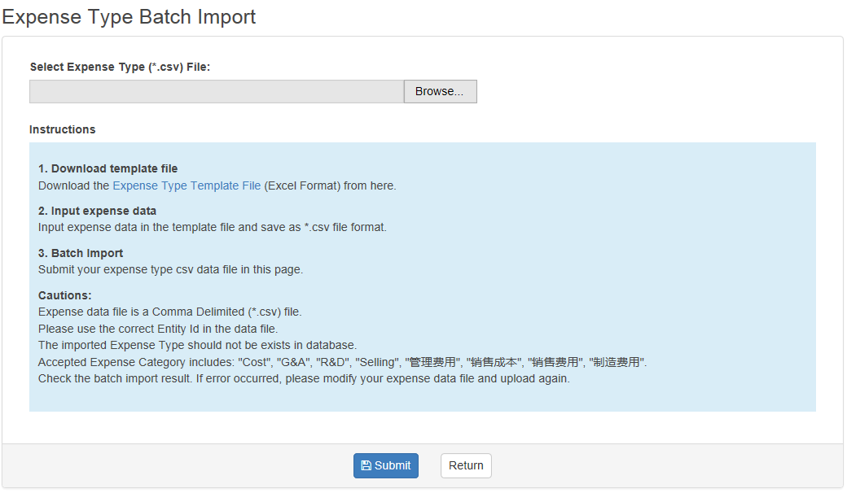

#### Data Dictionary

It’s where to manage the common data dictionary for Concur Data Conversion Universal. For example, the BU, Sector, Bank, ERP File Types etc.

If the Country attribute is null for a specified data item, it means this data items will be used in all countries. We simplify the data management in this way, say, the ERP file type will be used for all countries.

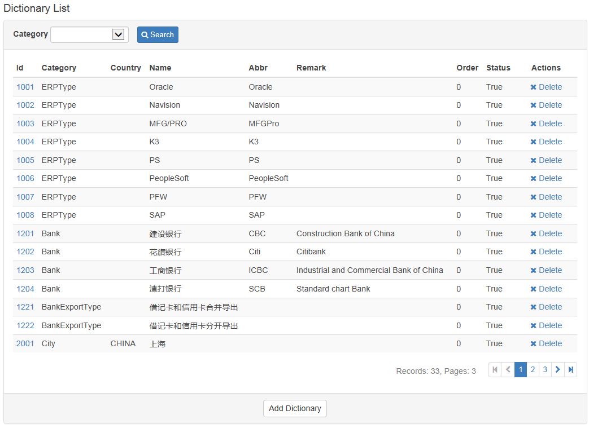

### Data Import

User can import concur expense data file through the Data Import menu as below. After data import, users will need to check and fix any Employee Exception, ExpenseType Exception, Bank Exception, PayeeType Exception before creating the barcode data.

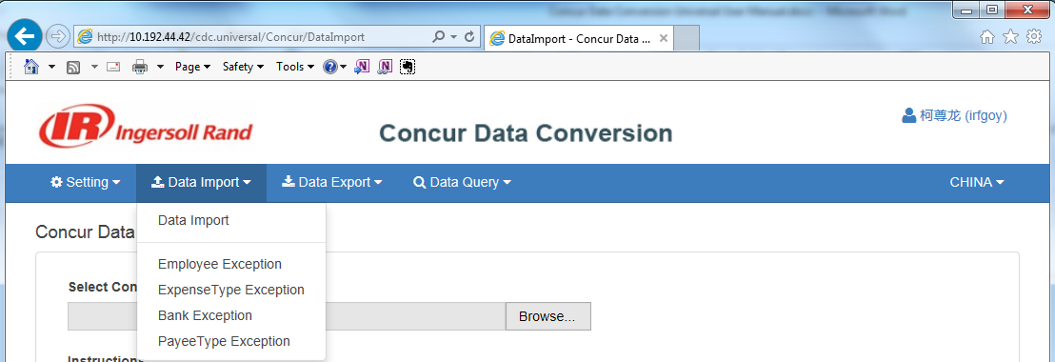

#### Data Import

It’s where to import the concur data file.

In order to improve the import performance and reliability, CDC universal adopts many new technologies in this step. Some of them are as below:

* Batch id verification instead of each row verification.
* Batch data import instead of inserting row by row.
* Check if the user uploads the correct file for current country to avoid a common error that user uploads the incorrect file for a specified country.

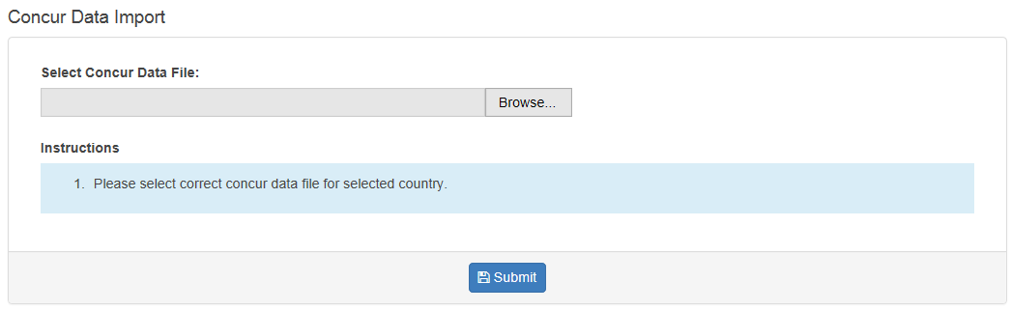

After successfully import, you will be noticed by information as below:

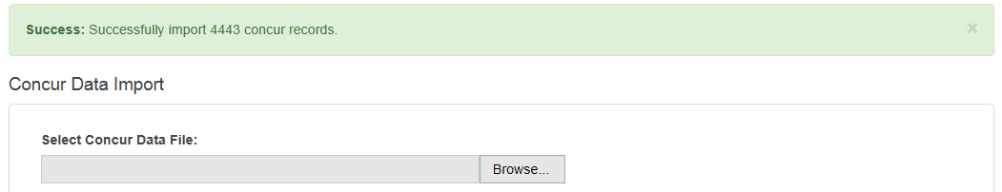

If you upload the incorrect data file, say, upload HongKong data file to China, you will get error information like this:



#### Employee Exceptions

User can view and fix employee exception in this page.

After fix all four type of data exceptions, user can click “Create Bar Code” to create the expense summary information for each employee and Key Id.

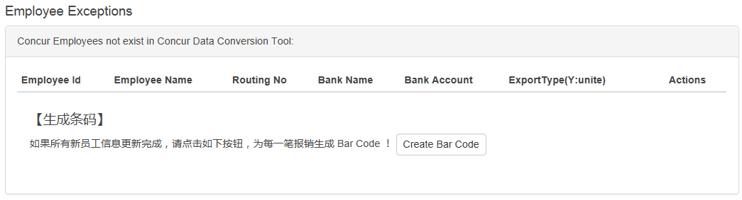

#### ExpenseType Exceptions

To view the expense type exceptions

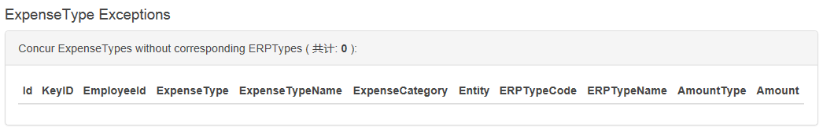

#### Bank Exceptions

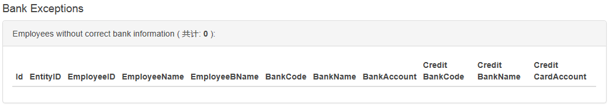

#### PayeeType Exceptions

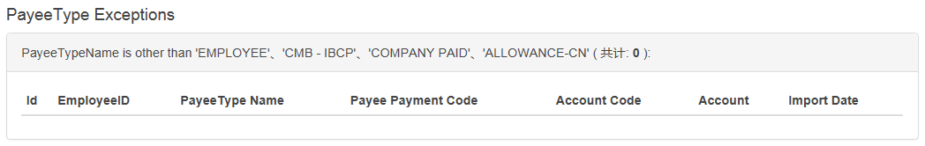

### Data Export

#### Data Export File List

Users can query and download export files in this web page, also you can click Data Export button to export data files.

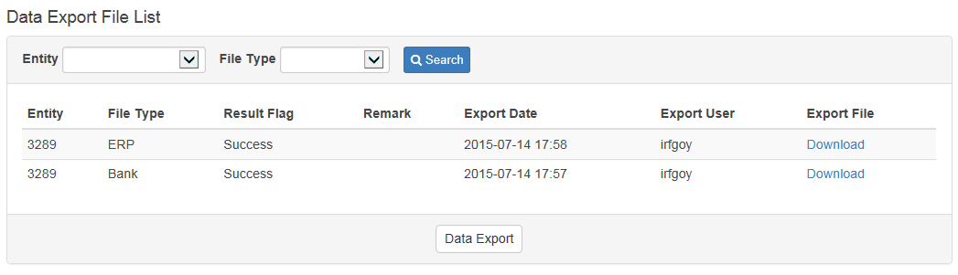

#### Data Export

Select the Entity and File type to export. Empty Entity means all Entities will be exported.

Also we use new technologies to improve performance and security in the data export process:

* Refactor all the stored procedure to get bank files, ERP files and PerDiem files.
* Using EPPlus instead of DCOM invocation. EPPlus is a .net library that reads and writes Excel 2007/2010 files using the Open Office Xml format (xlsx).
* Standardize the stored procedure naming convention and FileWrite interface to support multiple countries customization.

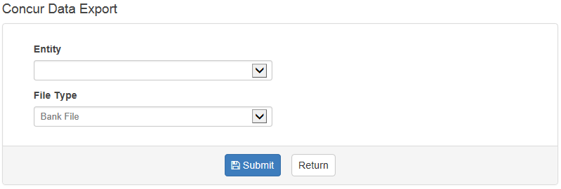

After successfully export, you will be noticed by the result and you can query and download files as below:

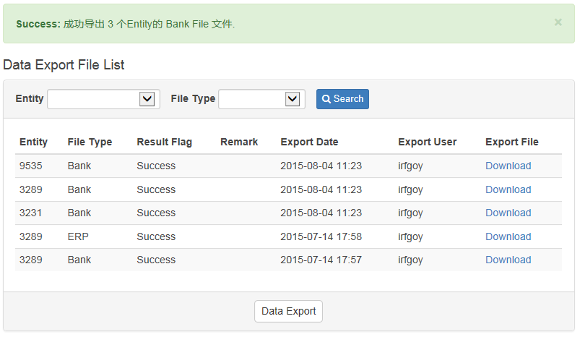

### Data Query

User can query the Barcode(financial summary) data and detailed concur expense data through Data Query menu.

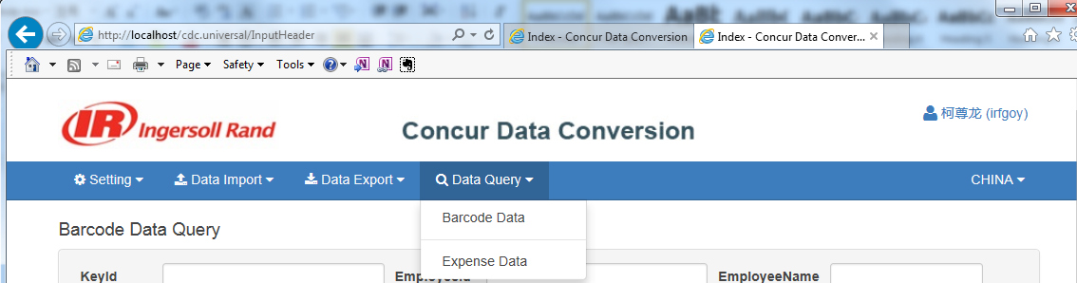

#### Barcode Data

Users can do the following tasks on this web page:

* Query and export barcode data.
* Export the unpaid Receipts report.
* Delete selected Receipts.
* Send emails to reminder employees for Receitps.
* Open Receipt Scanning dialog to scan Receipt

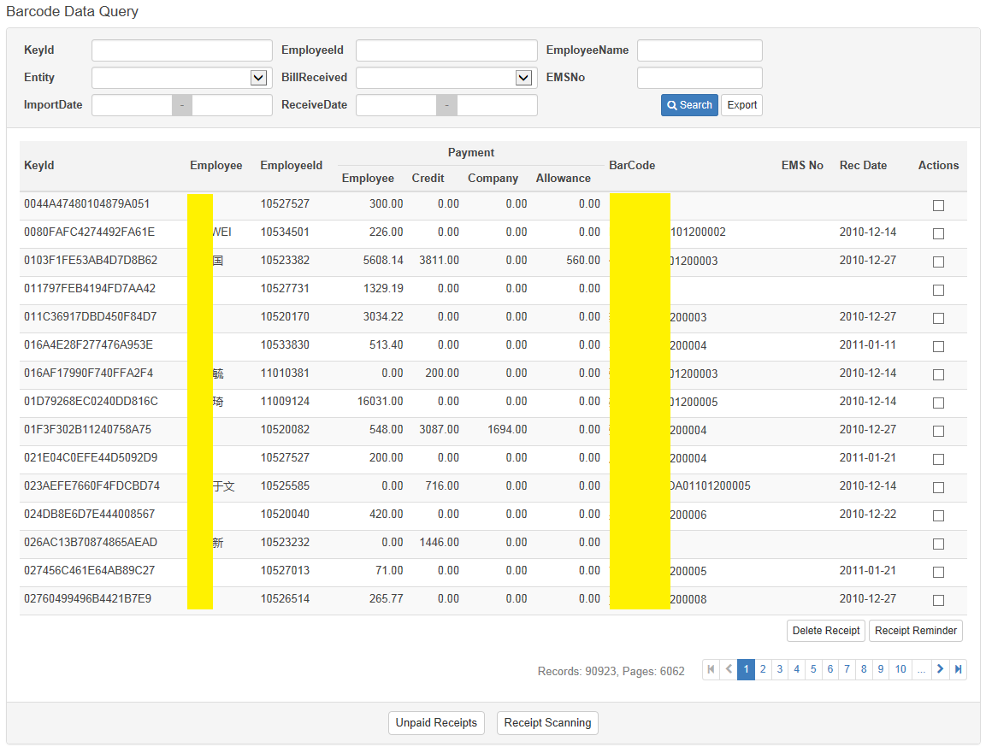

**Receipt Scanning:**

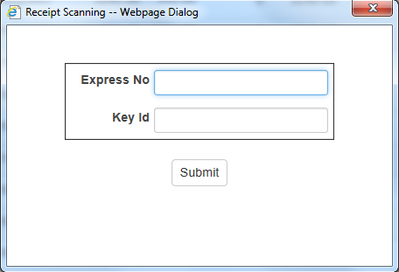

#### Expense Data

User can query and export detailed concur expense data on this web page.

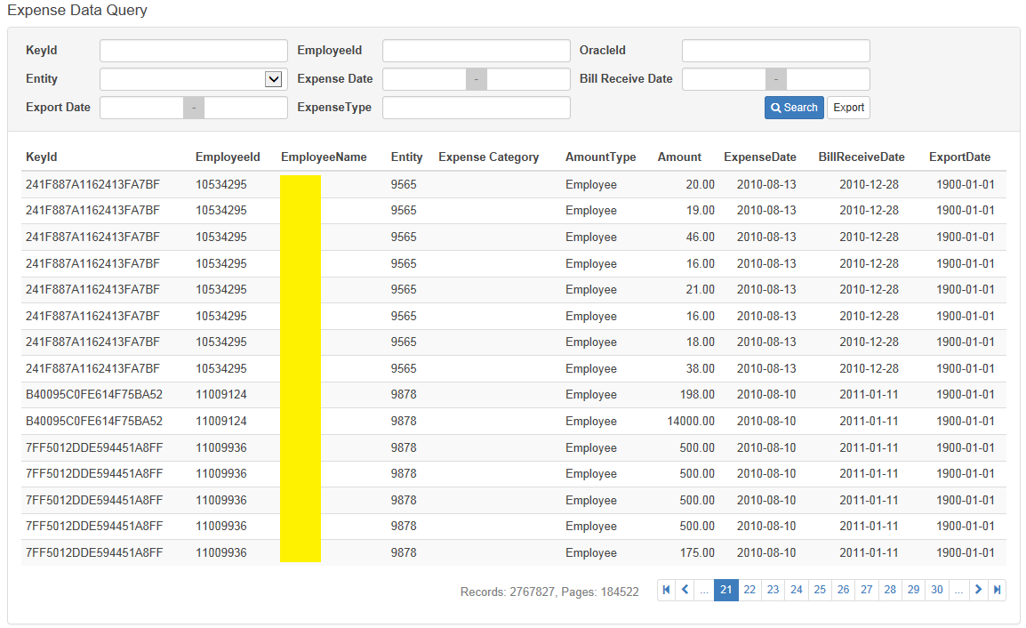

### Employee Receipt Query

Users can access <http://10.192.44.42/cdc.universal/Home/Receipt> to query receipt status.

This is a new requirement developed to allow employees querying their receipt status.

After login, the user can query data by KeyId, EMSNo and Employee Name.

